


Science Technician (part time)
Permanent – Term-Time

Start Date: 1st January 2026


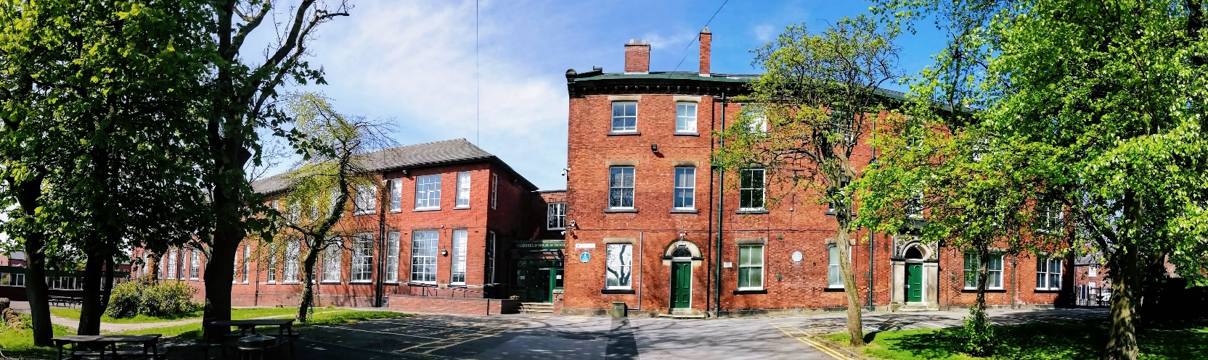

Dear Applicant

Thank you for expressing an interest in joining Fairfield High School for Girls. Within this pack you will find information about the school, the job vacancy and the application process. This is an exciting opportunity to work in an oversubscribed school and to make a contribution to shaping its future and continue building on its successes.

We are looking to appoint a motivated and multi-skilled Science Technician to join our Science Faculty. You will be working under the direction of the Faculty Leader for Science to assist with the organisation and preparation of lessons, working closely with staff and pupils. Other duties include basic housekeeping, stock control and maintenance of equipment. The role is varied and demanding with no two days the same. A Science background, or experience in a similar role within a school environment would be desirable however full training will be provided.

There is the opportunity to make this a full time role as we also require a part time design & technology technician. If this is something you would be interested in please address this in your application.

If you are an effective team player with a positive and proactive approach to work then we would like to hear from you. A willingness to be flexible in your approach will be essential. Acting in a professional manner and paying attention to detail and having the ability to carry out all duties in line with school expectations and health and safety guidelines are all qualities which are essential.
In your application, please link your skills, knowledge, experience and personal qualities to the requirements of the post, as described in the job description and person specification. We want you to tell us why you are the right person for the job.

We offer excellent support and CPD, including a powerful, whole school focus on the development of learning and teaching. If you wish to arrange a visit to the school, or to discuss this role, please contact the Faculty Leader, Dr Cahill, at acahill@fairfieldhighschool.co.uk

Fairfield is a great place to work; teachers are able to teach and pupils make outstanding progress due to our high standards and expectations. However, we acknowledge that there is always room for improvement and we strive to be the very best we can. If you wish to work in such an environment, please give us your serious consideration.

I look forward to receiving your application and thank you in advance for the interest you have shown.
I encourage you to visit our website to get a sense of who we are as a school and all that we have on offer.

Yours sincerely
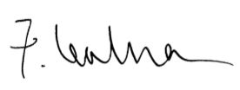
Miss Fee Lealman - Headteacher
Our School

As a high performing school, we offer a rich, broad and engaging education for all our young people. Now part of the Stamford Park Trust, Fairfield High School for Girls is a successful single sex school, of just under 1,000 11-16 year olds. The school enjoys an enviable reputation within its locality. It is extremely popular and has been significantly oversubscribed in recent years. It attracts pupils from more than 35 different primary schools within four different local education authorities.

We deliver an outstanding quality of education and because of this, Fairfield has a consistently strong history of excellent academic results. Our pupils work hard as they progress through a carefully planned, knowledge-rich curriculum to develop their understanding and skills to achieve outstanding grades across the curriculum. Our Progress 8 score for 2024 was +0.53 for all pupils and +0.65 for disadvantaged pupils. In 2024, Fairfield pupils achieved an amazing 118 grade 9s or equivalent D* vocational results.

The vision

The curriculum lies at the heart of all we do as a school. Our curriculum experience has breadth and challenge and is planned to meet all pupils’ learning needs. Through the curriculum pupils acquire a wide breadth of knowledge which in turn enables the application of skills, supporting progression to the next stage of learning. It poses questions and pursues answers. Through a rigorous academic focus, we aim to provide the very best learning experiences in Mathematics, English, the Arts, Sciences, Languages, Technology, Humanities and Computing.

Our pupils experience a curriculum which not only prepares them for their chosen learning pathway in further education or employment, but develops and encourages a deeper fascination and understanding of the world in which they live, their own values and those of others from differing belief systems. The impact of belonging to our school community reaches far beyond the academic. Through our strong ethos and wider curriculum, a rich set of enrichment experiences is offered; experience days, trips and visits, extra-curricular activities and the modelling of desired values and behaviours to develop character, resilience and a growth mind-set. This whole learning experience from Years 7 to 11 develops cultural understanding, aspiration and a curiosity about the world we live in. It develops pupils academically, emotionally, socially and morally.

We want our pupils to be educated citizens who appreciate the very best of human creativity and achievement. Who contribute, participate and engage with all aspects of their school experience to think about the people they aspire to be and the kind of world they aspire to create. Through the lived daily experience of school life, we inspire and support pupils to achieve and guide them to be:

To inspire pupils to achieve and guide them to be:

- Successful learners who enjoy learning, make outstanding progress, achieve outstanding academic results and are ready to meet the challenges of lifelong learning and the world of work;
- Confident individuals who are fully engaged in the life of the school and are able to live safe, healthy and fulfilling lives;
- Responsible citizens who are able to make a positive contribution to life in Modern Britain and beyond.
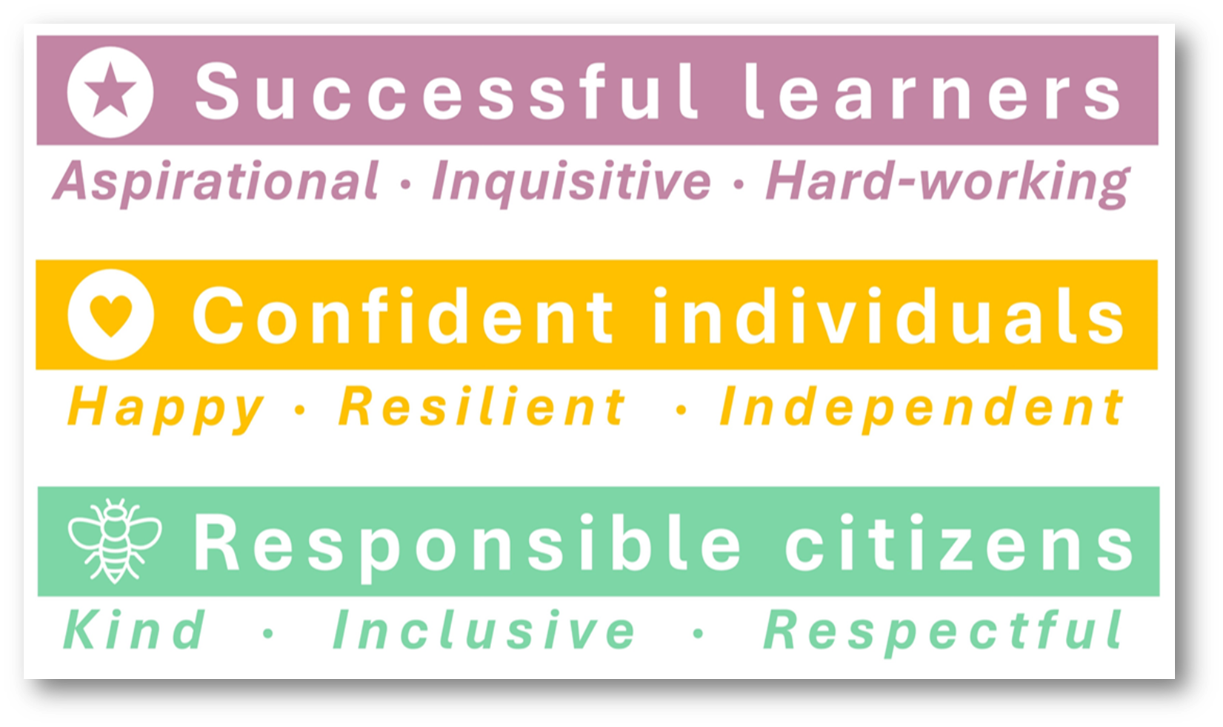

The school’s purpose

For the Trustees, Executive Leadership Team, Headteacher, Senior Leadership Team and all staff to work together within a tradition of care and service to promote the highest academic standards for all our pupils. Education at Fairfield High School for Girls is a transformational experience, which is realised through daily personal and academic excellence. We have very high expectations of behaviour and appearance reflecting excellent standards in the classroom and we pride ourselves on achieving outstanding progress for all. Our vision is to ensure that Fairfield pupils are successful learners, confident individuals and responsible citizens.

As a truly exceptional forward thinking school with high expectations for all learners through a relentless approach to overcoming barriers to learning and evidenced by high standards of achievement across all ages, regardless of background.

- A learning centred school which strives to nurture and develop the talents of all of its pupils.
- A vibrant and aspirational school community characterised by strong relationships between staff and pupils, underpinned by pride, ambition and a commitment to achievement and enrichment for all.
- A school community where all staff are committed to the ‘lifelong learning’ ethos running through personalised professional development underpinned by a collaborative coaching culture which promotes and nurtures all staff to sustain excellence and develop further.
- A school that truly works in the community, with the community and for the community.
- A school that provides a relevant, purposeful and inspiring curriculum for all pupils enabling them to be active citizens in a modern diverse British and global community.

We want everyone working in a caring school where everyone is valued and everyone values relationships. Our emotionally intelligent school community will celebrate individual differences and people will understand how their actions will impact upon, and be perceived by, those they affect. We expect all members of our school community to be the best they can be and help others to be the best that they can be by valuing ‘outstanding progress for all’.

Staffing

We have a very capable and talented team of staff. The Senior Leadership Team consists of the Headteacher, a Senior Assistant Headteacher and five Assistant Headteachers. The Senior Leadership Team are supported by the Executive Leadership Team, the Headteacher’s PA, the Assistant School Business Manager and the Company Secretary. We have circa 65 teaching staff and 45 support staff.

As part of the Stamford Park Trust, the school is also supported by a committed Trust Board and a Local Governing Body, the members of which have a diverse range of skills and expertise.

We are strongly committed to the development of our staff. We use external courses to support colleagues but also believe firmly in the benefits of internal expertise – sharing through coaching and ‘in-house’ best practice sessions. We also work with a group of other schools to support teacher training in middle management and excellent classroom practice.

Our Vacancy

Start Date: 1st January 2025

Closing Date: 9.00am on Friday 4th July 2025

Grade/Salary: Grade 7 £25,584
Actual Salary £13,307

Contract Type: Permanent, part time 22.5 hours per week, Term time only

Interview Date: w/c Monday 7th July 2025 – date to be confirmed

Application Process
Please download, complete and return the application form by the closing date specified. Candidates are asked to complete all the relevant sections of the application form and to submit a supporting statement, addressing the criteria listed on the person specification. This should be no longer than two sides of A4 paper (minimum font size 10). You may include examples from previous paid, unpaid or voluntary experience.

Prospective candidates are encouraged to submit their applications as soon as possible as the school reserves the right to close the advert should we feel able to appoint an appropriate candidate during the application process.

Please ensure that you provide an up-to-date email address with your application as we contact candidates electronically rather than by post.

The completed application form should be emailed to recruitment@fairfieldhighschool.co.uk
Or posted to: Recruitment – Admin Department
Fairfield High School for Girls
Fairfield Avenue
Droylsden
Manchester
M43 6AB

Please note that due to the volume of applications we receive, we will only be able to contact candidates who have been selected for interview. If you do not hear from us within two weeks of the closing date, please assume that we will not be calling you for interview on this occasion. For additional information about the school please visit the website www.fairfieldhighschool.co.uk

Background Checks and Safeguarding Pupils
Fairfield High School for Girls is committed to safeguarding and promoting the welfare of children and young people and expects all staff and volunteers to share this commitment. The position advertised is subject to an Enhanced Disclosure and Barring Service Check, medical clearance, satisfactory references, qualification checks and eligibility to work checks under the Asylum and Immigration Act.

Thank you
Thank you for considering Fairfield High School for Girls and we look forward to receiving your application.

Job Description
Science Technician (part time)
Permanent – 22.5 hours per week, term-time only

Responsible to:
- The Headteacher
- Faculty Leader for Science

Post Purpose:
- To support learning by assisting teaching staff in preparing materials and equipment for demonstration and practical lessons within the Science Faculty.
- The Science Technician will provide technical support, assist in practical lessons and carry out demonstrations.
- To give health and safety guidance to teachers and pupils.

Working relationships:
- Headteacher and Senior Leadership Team
- Faculty and Subject Leaders
- Teaching and Support Staff
- External Agencies

Specific Duties and Responsibilities:

- To contribute to operational functions by providing practical support and effective organisation of activities.
- Provide and prepare all equipment, chemicals and specimens for practical sessions and examinations, including constructing, setting up and dismantling equipment as required.
- Advise and support staff in the safe and proper use of equipment and contribute to demonstrations as required.
- Coordinate the maintenance of the laboratories and equipment, including carrying out minor repairs to apparatus following standard procedures in accordance with health and safety requirements.
- Undertake regular safety checks, reporting any faults appropriately.
- Ensure all resources are stored securely.
- Maintain a log of work requests and actions taken.
- Order equipment and supplies as necessary to support the delivery of the curriculum.
- Receive and check deliveries, keeping accurate records for materials and equipment.
- Keep accurate financial records, monitoring income and expenditure.
- Undertake general administration duties to support the Faculty.
- To carry out such duties which reasonably correspond with the general character of the post and are commensurate with its level of responsibility.
- Ensuring a healthy, safe and productive working environment, through the routine maintenance and cleaning of equipment, laboratories and prep rooms.
- To undertake appropriate and relevant training, keeping up to date with current procedures and practices.
- Preparation of standards and solutions, materials and cultures for living organisms.
- Ensuring the healthy and safe storage and availability of suitable resources (including checking the condition of chemicals and equipment).
- Checking laboratory services and facilities and reporting faults as necessary.
- General cleaning of laboratory sinks, benches, surfaces and fixed and used equipment.
- Ensuring safe treatment and disposal of waste/expired materials, including hazardous substances, in accordance with current guidelines, and responding to actual/potential hazards.
- To become a nominated First Aider, responding to calls as required (full training will be provided).
- To carry out other duties that may reasonably be required by the Headteacher, SLT and Faculty Leader.
Professional Development:

- To continue own professional development as agreed with your line manager.
- To attend and participate in appropriate training meetings and other learning activities.
- To actively engage in the Performance Management process for support staff.
- The develop constructive working relationships and communicate effectively and professionally with other staff.

Staff Meetings:

- Participating in meetings at the school, which relate to the curriculum for the school or the administration and organisation of the school, including pastoral arrangements.

Safeguarding and Equality:

- To have a thorough understanding of up-to-date safeguarding requirements and best practice.
- To demonstrate an understanding and acknowledgement of the individual’s responsibility for promoting and safeguarding the welfare of children and young people.
- To demonstrate a commitment to supporting and promoting safeguarding, pupil welfare, equality and diversity.
- To maintain an environment which feels safe and enables pupils to report any concerns or complaints.

School Ethos:

- To fully comply with the school’s Policy for Child Protection and Safeguarding (and related policies) to promote and safeguard the wellbeing of all young people at all times.
- To play a full part in the life of the school community, to support its distinctive mission and ethos and to encourage and ensure staff and pupils follow this example.
- To support the school in meeting legal requirements for worship.
- To promote actively the school’s corporate policies.
- To comply with the school's Health and Safety policy and undertake risk assessments as appropriate.
- To proactively promote an atmosphere of mutual support, respect, recognition and celebration of the diversity in our school.
Whilst every effort has been made to explain the main duties and responsibilities of the post, each individual task undertaken may not be identified.
The school will endeavour to make any necessary reasonable adjustments to the job and the working environment to enable access to employment opportunities for job applicants with disabilities or continued employment for any employee who develops a disabling condition.
This job description is written at a specific time and is subject to change as the demands of the school and the role develops. The role requires flexibility and adaptability and employees of the school need to be aware that they may be asked to perform tasks and be given responsibilities not detailed in this job description.
The person appointed must at all times work within the requirement of the Health and Safety at Work Act 1974, current Health and Safety legislation and the school’s policies and procedures.
Fairfield High School for Girls is part of the Multi Academy Trust, Stamford Park Trust, who is the employer for all staff.

Person Specification – Science Technician
Qualifications/Training/Knowledge | Essential | Desirable
A good standard of general education.
Well-developed Maths and English skills (by qualification or experience).
Willingness to undertake additional qualifications and training relevant to the role.
Other relevant qualifications.
Evidence of other types of relevant CPD.
A first aid qualification/certificate.
Experience/Skills
A successful record of employment.
Experience of working with young people in a school environment.
Classroom experience at primary and/or secondary school level.
Supporting literacy and numeracy across a range of subjects the curriculum and delivering interventions.
Participation in, and commitment to, extension and extra-curricular activities.
Improving the practice of others.
Competencies/Abilities
Promote and safeguard the wellbeing of all young people.
Develop positive relationships with pupils and staff.
Communicate highly effectively with a wide range of audiences.
Demonstrate yourself as a role model in terms of hard work, commitment to best practice in learning and teaching, personal presentation and attitude to all members of the school community.
Work independently and show initiative.
Support the school ethos of high standards of behaviour for learning.
Understand classroom roles and responsibilities and your own position within these.
Self-evaluate learning needs and actively seek learning opportunities.
Support the school ethos of high standards of behaviour for learning.
Deal sensitively with people and resolve conflicts.
Highly organised, with great attention to detail.
Ability to organise and prioritise work load and meet predetermined deadlines.
Ability to accept and promote new ideas.
Follow and document detailed instructions.
Professionally develop other colleagues.
Personal Qualities
A growth mind-set and commitment to lifelong learning.
Exemplary attendance and punctuality.
Professional presentation and manner.
Demonstrate impact and presence.
Willingness to take a full part in the life of the school.
A genuine commitment to inclusive comprehensive education.
Pupil-centred educational principles rooted in a willingness to continuously improve learning and teaching across the school.
High profile with pupils, parents/carers, staff and other stakeholders.
An effective team member.
Ability to motivate, inspire, enthuse and engage learners in the subject areas.
Be able to initiate ideas, set own targets and meet own and other people’s deadlines.
Strong interpersonal skills with all.
Well-developed communication and organisational skills.
Problem solving ability and a solution focused approach to work.
Sensitivity and understanding to help build productive relationships with pupils.
Commitment to always maintaining confidentiality.
A flexible approach.
Ability to work under pressure and maintain high standards.


